A479-AM,N-NW-Haisla-Mask-Mustache-Wood-Late 20th century

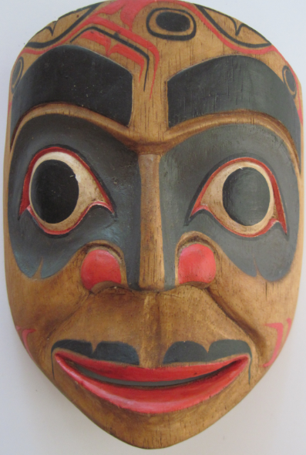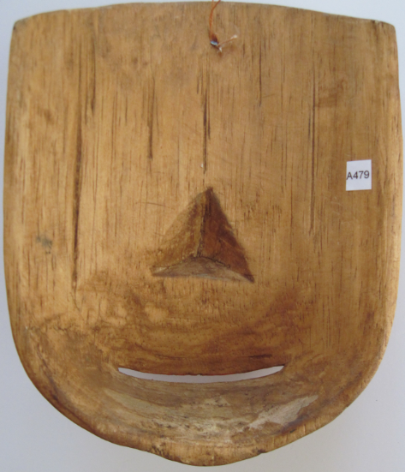

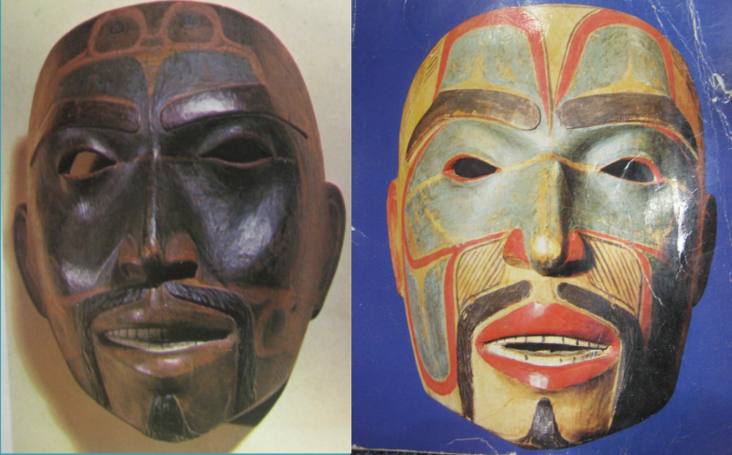

### Figs. 1-2. Haisla-Mask-Mustache-Wood-Late 20th century;

### Figs. 3-4. Historic Haisla Masks.

**Case no.: 8**

**Accession Number: A479**

**Formal Label:** Haisla-Mask-Mustache-Wood-Late 20th century

**Display Description:**

The salient feature of this Haisla-mask is its mustache that reflects the fact that it is a portrait of an individual, probably an ancestor.

The Haisla (Xa’islak’ala, X̄ Xai:sla) live at Kitamaat in the North Coast region of the Canadian province of British Columbia. Xa’islak’ala 'means (those) living at the river mouth, living downriver' at Kitimaat Village. Kitamaat is a Tsimshian name, applied by European explorers who asked their Tsimshian guides for the name of the place; it means "people of the snows" or "place of the snows". The Haisla name for Kitimaat is C'imo'ca (pronounced tsee-MOTE-sah) which means "snag beach." (WIKIPEDIA)

“Haisla is a North Wakashan language spoken by several hundred people. Haisla is geographically the northernmost Wakashan language. Its nearest Wakashan neighbor is Oowekyala. Haisla is related to the other North Wakashan languages, Wuikyala, Heiltsuk, and Kwak'wala. The Haisla language consists of two dialects, sometimes defined as sublanguages – Kitamaat and Kitlope (also known as X̣enaksialak’ala).” (WIKIPEDIA)

Before 1950 the Kitimat township was a small fishing village at the head of the Kitimat Arm of the Douglas Channel, a deepwater fjord.), the Haisla reserve, is a short 20 minute drive south of the town of Kitimat at the head of the Douglas Channel, a 90-km (56-mi) fjord that serves as saltwater corridor that connects the community and the town and port of Kitimat, which is the site of the aluminum smelter of Alcan Incorporated, to the Pacific Ocean. (WIKIPEDIA)

**LC Classification**: E78.N78

**Date or Time Horizon:** Late 20th century

**Geographical Area:** Kitimat, North Coast, British Columbia

**Map, GPS coordinates:** 54º02'57.72" N 128º37'42.07" W

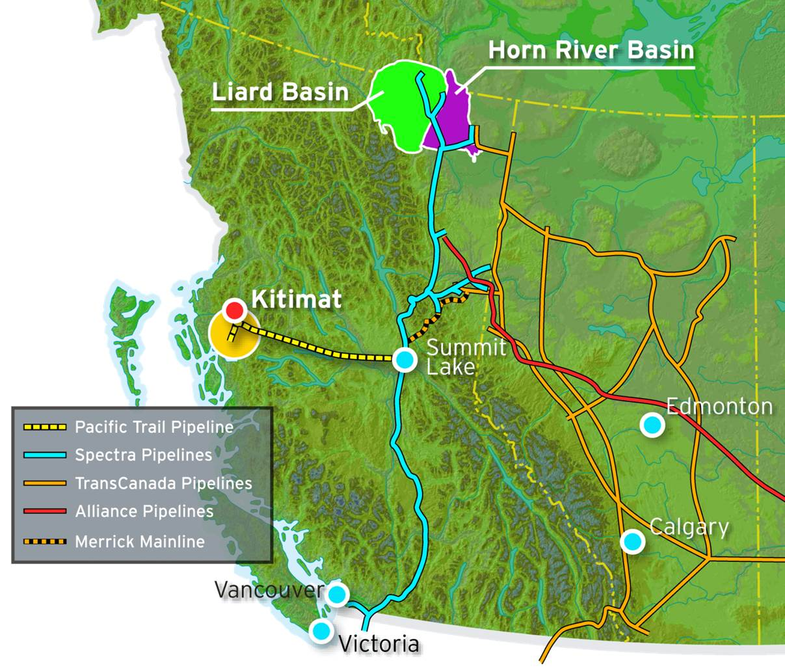

Fig. 5. Map of Kitimat. From http://www.chevron.ca/sfimages/default-source/default-album/maps/kitimat-lng-map-aug2015.jpg?sfvrsn=0

**Cultural Affiliation:** Haisla

**Media:** Wood, red and black paint.

**Dimensions:**

**Weight:**

**Condition: original**

**Provenance:** artist

**Description:**

Technically, the style and form of Haisla masks changed in tandem with access to iron tools and supplies made available after contact with early Russian explorers and European settlers (Holm 1965: 5; Malin 1978: 13; Jonaitis 1991: 39, 54; Masco 1995: 42). Metal carving tools were sharper and more efficient than their traditional counterparts, and modern synthetic paints allowed for more dramatic and durable coloration than did the plant and mineral based pigments previously used to decorate masks (Jonaitis 1991: 39, 54).

However, the rôle of the past is still evident in the conservatism among some sculptors who refer to the masks of the past in their work. In this respect, masks are highly valued by the Haisla as manifestations of ancestral spirits and supernatural beings. These supernatural entities are embodied through dance performance (Greenville 1998: 14). However, Northwest Coast tribes vary in their use of different myths, characters, and masks (Malin 1978: 47). Since each mask and accompanying dance programs are “owned” by particular families and passed down by elders and chiefs to their immediate and extended families, they have a certain conservatism in their presentation in the potlatch and seasonal festivals, accruing histories that incrementally transform their meaning (Gosden and Marshall 1999: 172), which is reflected in the way sculptors create new masks based on these transformations (Malin 1978:18-19; Ostrowitz and Jonaitis 1991: 251).

**References:**

Greenville, Bruce. 1998. “Introduction.” In Macnair, et al. 1999, pp. 14-16.

Hawthorn, Audrey. 1979. *Kwakiutl Art*. Seattle: University of Washington Press.

Holm, Bill. 1984. *Form in Northwest Coast Art in Indian Art Traditions of the Northwest Coast*, ed. Roy L. Carlson. Burnaby, B.C.: Archaeology Press & Simon Frasier University.

1983. *The Box of Daylight: Northwest Coast Indian Art*. Seattle: Seattle Art Museum and University of Washington Press.

1972. *Crooked Beak of Heaven*. Seattle: Seattle Art Museum and University of Washington Press.

1965. *Northwest Coast Indian Art*. Seattle: Seattle Art Museum and University of Washington Press.

Boas, Franz; George Hunt. 1902-1905. *Kwakiutl texts, First and Second Series*. Memoirs of the American Museum of Natural History, v. 14, pt. 1; Publications of the Jessup North Pacific Expedition, v. 10, pt. 1. New York: Knickerbocker Press

Jonaitis, Aldona; Douglas Cole; Stacy Alyn Marcus; Lynton Gardiner. 1991. *Chiefly Feasts: The creation of an exhibition in Chiefly Feasts: The Enduring Kwakiutl Potlatch.* New York and Seattle: American Museum of Natural History and University of Washington Press.

Macnair, Peter. 1998. *Power of the Shining Heavens in Down from the Shimmering Sky: Masks of the Northwest Coast.* Vancouver and Seattle: Douglas & McIntyre and University of Washington Press.

Macnair, Peter; Robert Joseph; Bruce Grenville. 1999. *Down from the Shimmering Sky: Masks of the Northwest Coast.* Vancouver, British Columbia: Dover.

Malin, Edward. 1999. *Northwest Coast Indian Painting: House Fronts and Interior Screens*. Portland, OR: Timber Press.

1978 *A World of Faces: Masks of the Northwest Coast Indians*. Portland, OR: Timber Press.

Masco, Joseph.1995. “‘It is a Strict Law That Bids Us Dance’: Cosmologies, Colonialism, Death, and Ritual Authority in the Kwakwaka'wakw Potlatch, 1849 to 1922,” *Comparative Studies in Society and History* 37 (1): 41-75.

Ostrowitz, Judith, and Jonaitis, Aldona. 1991. “Postscript: The Treasures of Siwidi in Chiefly Feasts: The Enduring Kwakiutl Potlatch” In Aldona Jonaitis, et al., 1991.

Pollock, Donald**.** 1995. “Masks and the Semiotics of Identity,” *The Journal of the Royal Anthropological Institute* 1(3): 581-597.

Sawyer, Alan R. 1983. “Toward More Precise Northwest Coast Attributions: Two Substyles of Haisla Masks.” In Bill Holm, *The Box of Daylight: Northwest Coast Indian Art*. Seattle: Seattle Art Museum and University of Washington Press, pp. 143-147.